**ITNW 1335 Lab  
Creating a Billing Alert in AWS**

You can monitor your estimated AWS charges by using Amazon CloudWatch. When you enable the monitoring of estimated charges for your AWS account, the estimated charges are calculated and sent several times daily to CloudWatch as metric data.

Billing metric data is stored in the US East (N. Virginia) Region and represents worldwide charges. This data includes the estimated charges for every service in AWS that you use, in addition to the estimated overall total of your AWS charges.

The alarm triggers when your account billing exceeds the threshold you specify. It triggers only when actual billing exceeds the threshold. It doesn't use projections based on your usage so far in the month.

If you create a billing alarm at a time when your charges have already exceeded the threshold, the alarm goes to the ALARM state immediately.

**Tasks**

Enabling billing alerts  
Creating a billing alarm

**Enabling billing alerts**

Before you can create an alarm for your estimated charges, you must enable billing alerts, so that you can monitor your estimated AWS charges and create an alarm using billing metric data. After you enable billing alerts, you can't disable data collection, but you can delete any billing alarms that you created.

After you enable billing alerts for the first time, it takes about 15 minutes before you can view billing data and set billing alarms.

**Requirements**

You must be signed in using account **root** user credentials or as an IAM user that has been given permission to view billing information.

**To enable the monitoring of estimated charges**

1) Log into your AWS account at aws.amazon.com by hitting the Sign in to Console button. Make sure Root User is selected.

2) Once in, click on **Services** at the upper left and then select **AWS Budget** under **AWS Cost Management**.

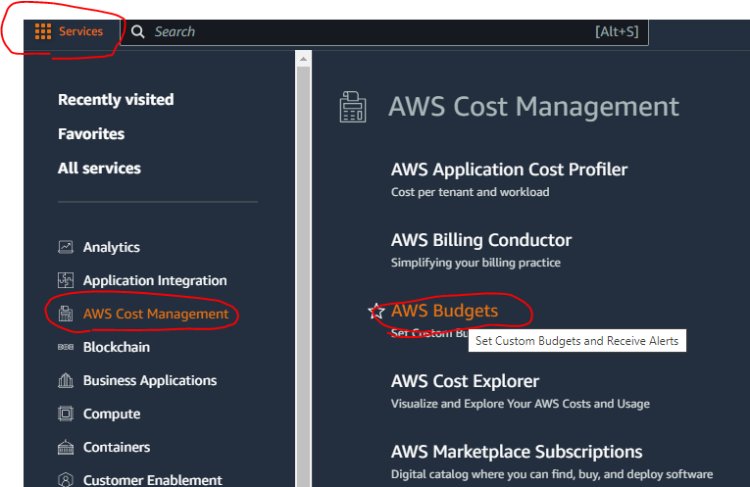

2) In the navigation pane (left panel), choose **Billing Preferences**.

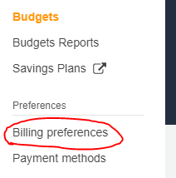

3) Click the **Edit** button next to *Alert preferences*.

4) Check *Receive AWS Free Tier alerts* and enter the email address you want to receive the alerts.

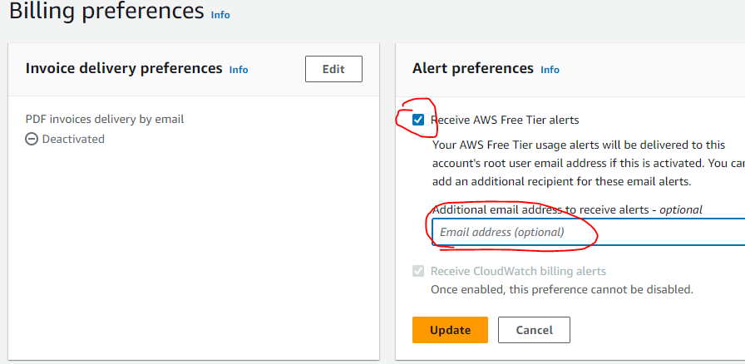

**Creating a Billing Alarm**

**To create a billing alarm using the CloudWatch console**

1) Under Services, click **CloudWatch** under **Management & Governance**.

2) If necessary, change the Region to US East (N. Virginia). Billing metric data is stored in this Region and represents worldwide charges.

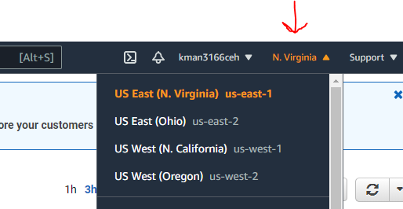

3) In the navigation pane, choose **Billing** under **Alarms**, then **Create Alarm**.

4) Click the **Select metric** button. In the *Metrics* section under the *Browse* tab, choose **Billing**, then **Total Estimated Charge**.

If you don't see **Billing** or the **Total Estimated Charge** metric, you may need to enable billing alerts.

5) Select the check box next to **USD** **EstimatedCharges**, and click **Select metric** button.

6) Under **Conditions**, choose **Static**.

7) For ***Whenever EstimatedCharges is***, choose **Greater**.

8) For ***than***, enter the monthly amount that must be exceeded to trigger the alarm. Type **5** in the box.

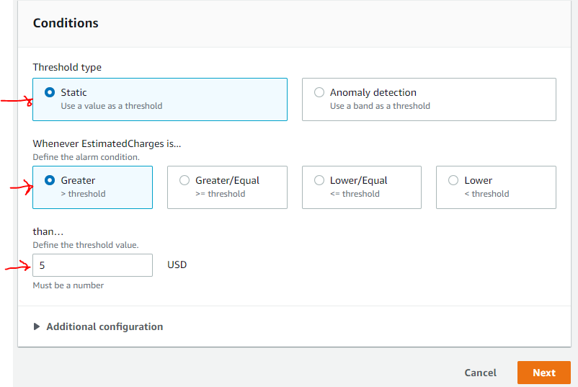

9) Choose **Next**.

10) Under *Notification*, for *Send a notification to the following SNS topic*, select **Create new topic**, type **5_Dollar_Alarm** in the box below and then your ACC email address (or any email address) in the Email endpoint…

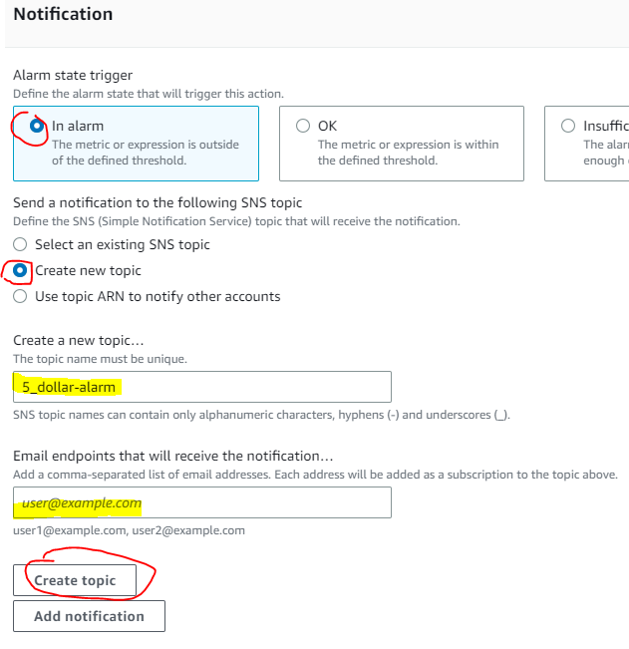

11) Click **Create Topic**. Now go to your email and click the **Confirm subscription** link. (Note: email end up in your Spam box)

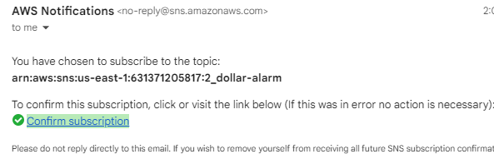  
  
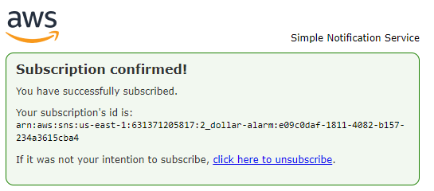

12) When confirmed, return to the AWS Console window and click **Next**.

13) Enter the name **Billing_Alarm1** and description of **This alarm triggers when amount goes above $5** for the alarm. Then choose **Next**.  
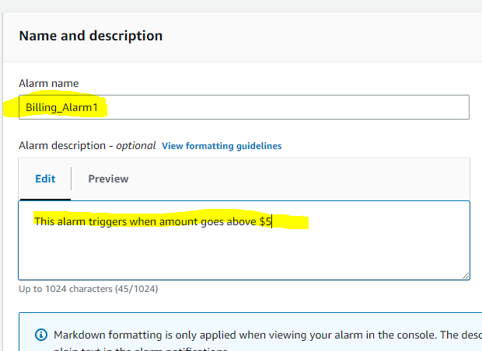

14) Under **Preview and create**, confirm that the information and conditions are what you want, then scroll down and click **Create alarm**.

15) **Open a Word Doc and paste the screenshot of the Billing alarm screen to Bb**. Make sure you capture the information I have circled in Red. Save Word Doc and submit to Bb.

**Screenshot**

